COP carry — the cushion, not the call
Long COP vs USD, 12-month NDF · 27 August 2026

This is not a peso appreciation trade. At a 12-month outright of 3,422 you are paid 8.6% to be wrong about direction — USDCOP can rise from 3,152 to 3,422 and you still break even. The question is not whether COP rallies further from a seven-year high. It is whether it gives back more than the cushion.
COP 12M IMPLIED  12.59%  CLNI12M BGN | USD 1Y SOFR OIS  4.02%  USOSFR1 BGN | GROSS CARRY  8.57%  locked at inception | SPOT  3,152  COP REGN | 12M BREAKEVEN  3,422  +8.6% vs spot

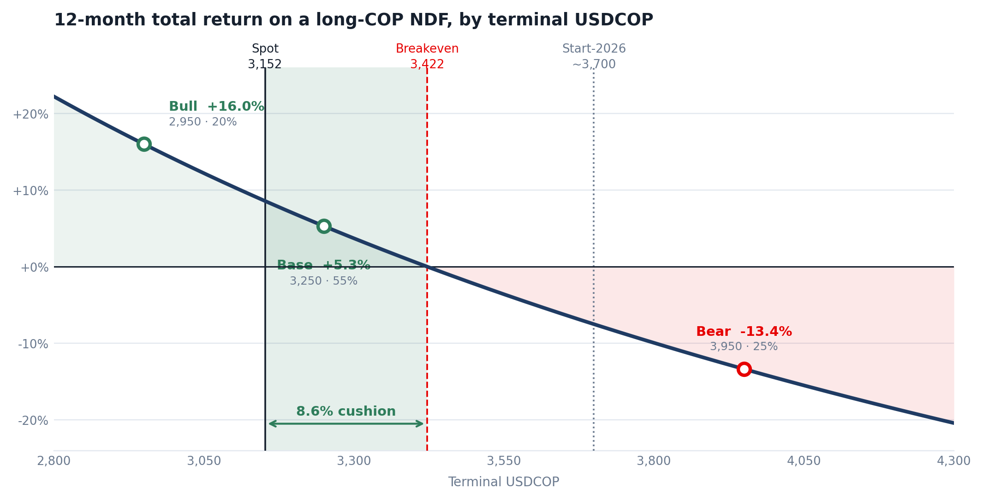
Carry is contractually locked at inception; terminal spot is the only variable. Shaded band is the breakeven cushion.
Scenarios
SCENARIO | PROB | USDCOP | SPOT | CARRY | TOTAL | DRIVER
Bull  Fiscal credibility delivered | 20% | 2,950 | +6.8% | +9.2% | +16.0% | COP 60tn spending freeze converts into passed legislation; fiscal rule restored; ratings outlook stabilises. Upside capped by Banrep's USD 4bn reserve accumulation.
Base  Election priced, programme not | 55% | 3,250 | -3.0% | +8.3% | +5.3% | Seven-year high partially retraced. Congress delivers a diluted adjustment; Banrep on hold at 12%; monthly USD put auctions lean against further strength.
Bear  Adjustment stalls in Congress | 25% | 3,950 | -20.2% | +6.8% | -13.4% | Pacto Historico blocks the fiscal package; rule stays suspended; further downgrade below BB-; oil shock. Still 23% inside the 2025 high.
Probability weighted | 100% |  |  |  | +2.8%

What you have to believe to say no
Expected return holding the bull at 20% and shifting weight from base to bear:
Bear probability | 10% | 15% | 20% | 25% | 30% | 35% | 40% | 45%
Expected return | +5.6% | +4.6% | +3.7% | +2.8% | +1.8% | +0.9% | -0.0% | -1.0%
Expected return turns negative only above roughly 40% weight on a full round-trip to 3,950 — a level Colombia traded through as recently as January. That is the honest test of the trade, and it is a demanding one.
The differentiator is not the level of carry. It is the direction.
- COP is not the highest-carry EM currency, and the note should not claim it is. Brazil pays more: Selic at 14.00% against 1y SOFR at 4.02% is roughly 10.0% nominal, against 8.57% here. Turkey, Egypt and Nigeria are multiples higher. Mexico, at a 6.50% policy rate, is not in the conversation.
- COP is the only major LatAm carry currency whose central bank is still tightening. Banrep has raised 175bp this year — 100bp in March to 11.25%, 75bp in June to 12.00% — and held on 31 July on a 4–3 vote, with three directors wanting a further 50bp. Copom has cut four consecutive meetings to 14.00% and the Focus survey sees 13.75% by December. Over a 12-month horizon the BRL cushion decays and the COP cushion does not. That is the case, not the headline number.
- The offsetting official constraint is explicit. Banrep announced a programme to accumulate up to USD 4bn of reserves over two years through monthly put auctions, the first on 3 August for up to USD 400mn. The central bank has chosen to lean against peso strength with the balance sheet rather than the policy rate. That caps the bull case and should be stated as the reason it is capped.
- Real carry is high but not exceptional. A 12.0% policy rate against 6.14% June inflation is a real rate near 5.9%, among the most restrictive settings in the region — but Brazil's is wider still. Sell the tightening bias, not the real rate.
Three corrections to the working file
1. The additive decomposition flatters the bear. Total return on a USD-notional NDF is (F − S) / S, not carry + (S₀/S − 1). Carry must be scaled by S₀/S. At the original bear of 3,800 the correct figure is −9.95%, not −8.48%; the error grows with the size of the move and always understates the loss. It also explains why the original breakeven of 3,422 did not return zero in the scenario grid.
2. The base case description is factually wrong on Colombia. “Both US and COP rates fall slowly” does not describe 2026. Banrep has hiked 175bp, inflation rose to 6.14% in June against an end-year consensus of 6.6%, and Fedesarrollo's August panel has the policy rate unchanged at 12% through December.
3. Every scenario is a Fed scenario. None is a Colombia scenario. The dominant risk to this position is domestic and fiscal: S&P cut Colombia to BB− in April on an expected 5.6% of GDP general government deficit, the fiscal rule remains suspended, the 2026 borrowing quota is close to exhausted, and the COP 60tn spending-reduction target has to pass a Congress in which Pacto Historico holds the largest Senate bloc. The peso has already priced the election; it has not priced the programme.
View
Constructive, at half size, with the balance held for a better entry.
What makes the position attractive is that the carry does not decay. Every other LatAm carry story is a race between the coupon and the cutting cycle — BRL pays 10% while Copom walks it down. Here Banrep is the only board in the region with directors voting for hikes, so twelve months of 8.6% is closer to actually being 8.6% than anywhere else in the region.
What argues against sizing up here is that the vol-adjusted number is less compelling than the headline. Against COP implied vol of roughly 12–14%, an 8.6% cushion is a carry-to-vol ratio under 0.7 — adequate, not exceptional — in a currency that printed 5,118 last year, so the left tail is not symmetric with the vol estimate. Entry also follows an 18% run, into crowded positioning, against a central bank that has said explicitly it will buy dollars against further strength.
The recommended structure is therefore half size now and half on a move toward 3,350–3,400. The fiscal package reaches Congress in the first months of the new term and is a genuine binary: Pacto Historico holds the largest Senate bloc and de la Espriella has no majority. If the package stalls, the entry improves and the carry is still there, because a stalled adjustment is precisely what keeps Banrep from cutting.
The reading to avoid is treating the +2.8% expected return as an appreciation call. It is not. It is a fair-but-not-generous premium for sitting through a legislative fight, and it should be sized accordingly.
Method and sources
Total return on a USD-notional NDF is (F − Sₜ) / Sₜ, decomposed as spot return S₀/Sₜ − 1 plus carry × S₀/Sₜ. The forward is computed from covered parity on the quoted differential, F = S₀ × (1 + carry); no separate NDF points are used, so the cross-currency basis is not isolated.
Rates and spot from Bloomberg: CLNI12M BGN Curncy, USOSFR1 BGN Curncy, COP REGN Curncy. USD LIBOR is not used — ICE ceased synthetic USD publication on 30 September 2024. Policy, inflation and rating references: Banco de la República (31 July 2026 decision, 5 August 2026 minutes), BBVA Research, S&P Global Ratings (8 April 2026), Banco Central do Brasil (5 August 2026).
Open item: the start-2026 reference of ~3,700 is derived from a reported ~18% year-to-date appreciation against an early-August level near 3,200 and should be confirmed against the Bloomberg series before publication. Scenario probabilities are judgemental.

